**Functionality guide**

## Group 5: Yanzhang Wu, Thanwa Chaichankanchang, Boling Zhang, Xingyun Zeng

# Description:

It’s a warehouse management system for clothing store employees to use. The system is designed for two roles, user and administrator. Users can register and log into the system, as well as check or edit the records of items. Administrators can use this system to management user accounts and admin accounts.

# Highlights:

1. Frontend and backend separation.
2. Animated Login page and signup page.
3. Redirecting anonymous users to index page if they try to access management pages.
4. CRUD are implemented within one html page.
5. Frontend validation and backend validation.

# Two Roles of User with Different Permission

We create two roles of users - administrator and regular user, to perform functions with different permissions to the different databases. Users can choose their roles on the index page.

Figure 1. Index Page

# Section 1: Login and Signup

1. The login page has the frontend validation. If user inputs don’t meet the requirements, the login request will not be processed.

Figure 2. Frontend Validation—User Login Page

1. When the users’ inputs pass the frontend validation, the backend will check if the username and password match the records in the database. If the validation fails, the error message will be displayed.

Figure 3. Backend Validation—User Login Page

1. Users could register through the Signup page in which frontend validation applies as well.

Figure 4. Frontend Validation - User Signup Page

1. The Signup page also includes backend validation. If there are duplicated usernames to be registered, the error message will be displayed.

Figure 5. Backend Validation - User Signup Page

1. If the user registers successfully, a successful message will be displayed. Then the page will redirect to the user Login page.

Figure 6. Signup Success. Redirect the Page

1. If the login is successful, the user will be directed to the itemManagement.html. An animation will be played during the page loading.

Figure 7. Loading Animation Before Displaying Page to User

1. Users can do CRUD manipulation on the item management table. After the successful login, itemManagement.html will display this table to the user automatically. Examples of CRUD will be discussed in Section 3.

Figure 8. Item Management

1. Administrators can access the tables of administrator management and user management. CRUD on these tables will perform manipulations on corresponding databases. After the successful login, the admin management table will be shown to the administrators by default. administrators can click the tags on the sidebar to switch between different tables.

Figure 9. AdminLogin.html

Figure 10. Display Admin Management by Default

Figure 11. Switch to User Management Table

# Section 2: Anonymous Guest Visits

1. Anonymous guests do not have permission to access itemManagement.html or Management.html. They will be redirected to the index page.

Screenshot 6: Error Message of Anonymous Access

Screenshot 7: Redirect to the Index Page

# Section 3: CRUD Manipulation of Data (user as an example)

## Add Record

1. Users can add records by clicking the “Add Record” button. It will display one row of input boxes for users to insert data. The “Add Record” button stays disabled until “Confirm Add” is clicked.

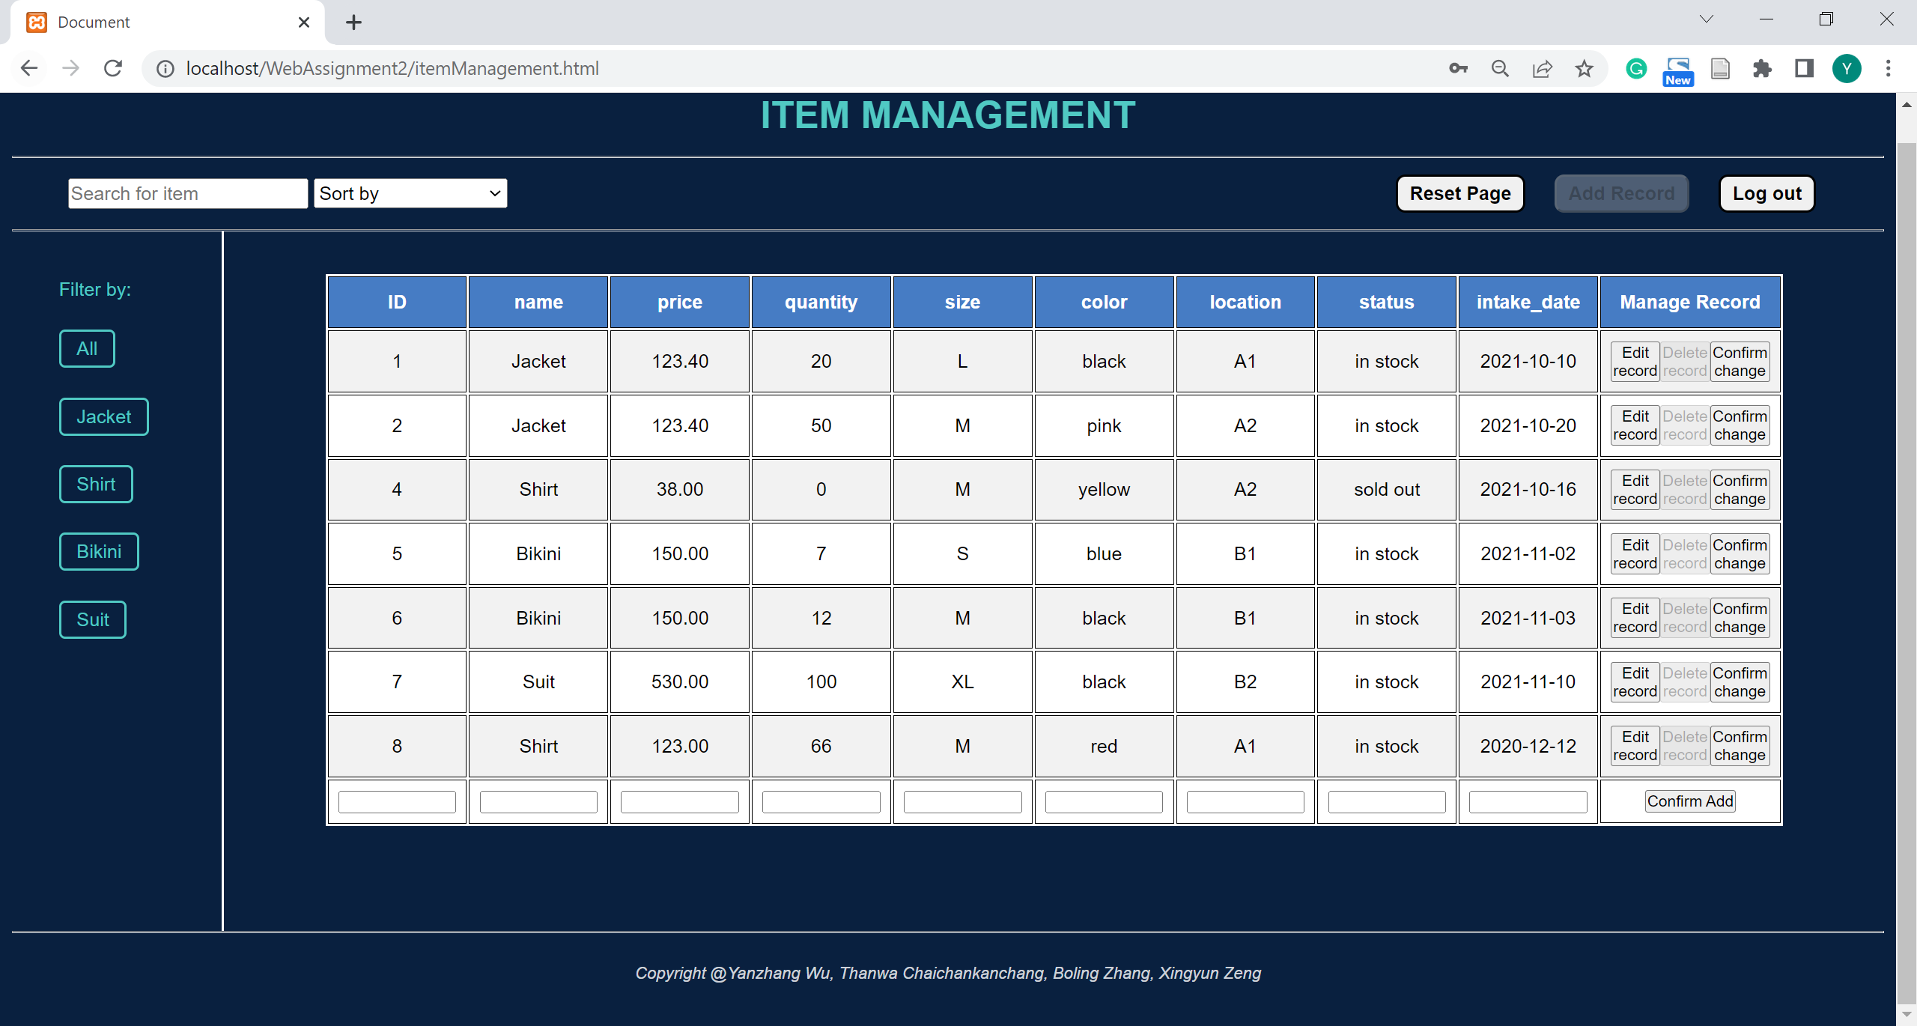

Screenshot 11: Input Boxes for Inserting Records

1. If users insert any invalid data into the boxes, the error message will let the user check the input again and the data insertion fails. For example, if users try to insert a string into the “Price” column, it will fail the validation.

Figure 12. Error Message of Backend Validation on the Input Value

1. The user should click the “Confirm Add” button to ensure the creation of the record, then continue other tasks.

Figure 13. Add Records with Success

1. If users leave the ID number empty, it will automatically increment the ID number based on the records.

Figure 14. Leave the ID Number Input Box Empty While Inserting Records

Figure 15. Auto-Increment of ID

## Edit Record

1. Users can edit the records by clicking the “Edit Record” button beside the records. Users should click the “Confirm Change” button after updating the records.

Figure 16. Edit Records with Success

1. Same as the case when users try to add invalid records to the table, if users change the values of records into invalid data, an error message occurs.

Figure 17. Error Message of Invalid Input When Edit

## Delete Record

1. To ensure the safety of data, users should click “Edit Record” before deleting records. The “Delete Record” button is disabled before users click the “Edit Record” button.

Figure 18. The Disabled “Delete Record” Button

Figure 19. The “Delete Record” Button is Enabled After Clicking the “Edit Change” button

Figure 20. Delete Records With Success

## Display Tables in Customized Manners

### Dynamic Searching

1. Users can search for item names in the search bar. Note that the matching of keywords is not case-sensitive.

Figure 21. Enter "s" In the Search Bar

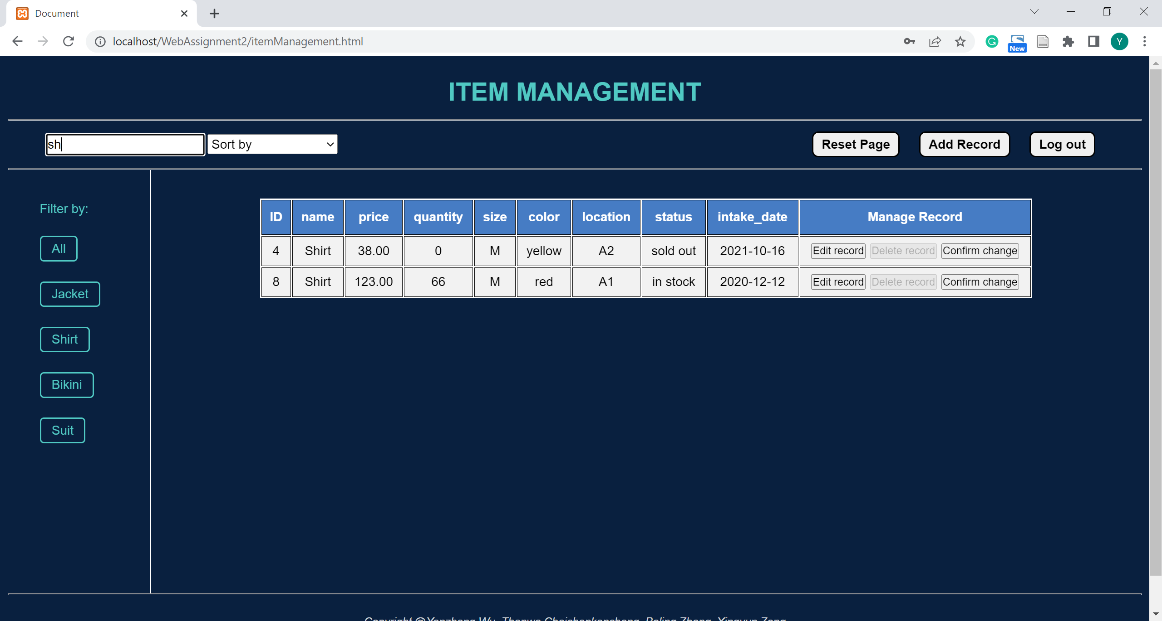

Figure 22. Enter "sh" In the Search Bar

### Sort

1. Users can use the “Sort by” option drop-down list to display the records in different orders. Based on the columns, it can display data either in ascending way or descending way.

Figure 23. Sort By Dropdown List

Figure 24. Sort by ID Descending

1. Users can use the combination of Search and Sort. For example, search “Sh” with the oldest intake date.

Figure 25. An Example of Search and Sort Combination

### Filters

1. Users can filter the records of items based on their categories. The category tags are listed on the sidebar. By clicking the different tags, users can filter the records.

Figure 26. Bikini Filter On Active

1. Users can use the combination of Filter and Sort. For example, filter “Suit” with the latest intake date.

Figure 27. An Example Of Filter and Sort Combination

### Reset

After displaying the table in different ways, users can click the “Reset Page” button to reset the table back to the default arrangement.

Screenshot 28: Reset the Table to the Default Arrangement

## Log out

By clicking the “Log Out” button, users will direct to the index page immediately.

Figure 28. Redirect to the Index Page after Logout